**CHAPTER 1 STORING INFORMATION IN TABLES**

**Notes about SQL**

■ SQL is the designated language for getting information from a relational database.

■ SQL says ***what*** information to get, rather than ***how*** to get it.

■ Basic SQL is easy to learn.

■ SQL empowers people by giving them control over information.

■ SQL allows people to handle information in new ways.

■ SQL makes information powerful by bringing it to people when they need it.

**1-5 Data is stored in tables**

■ In a relational database, all the data is stored in tables.

■ A table has two dimensions called columns and rows.

■ Tables can hold even the most complex information.

■ All operations begin with tables and end with tables. All the data is represented in tables.

**1-6 A row represents an object and the information about it**

■ A row contains data for one object, event, or relationship.

■ All the rows in a table contain data for similar objects, events, or relationships.

■ A table may contain hundreds or thousands of rows.

■ The rows of a table are not in a predictable order.

**1-7 A column represents one type of information**

■ A column contains one type of data about each row of the table.

■ Each column has a name.

■ Each column has a datatype. The most important datatypes are:

• Text

• Numbers

• Dates with times

■ Some columns accept nulls, and others do not. A null is an unknown value.

■ Each column has a position within the table. In contrast to rows, the columns of a table form an ordered set. There is a first column and a last column.

■ Most tables have 40 columns or fewer.

**1-8 A cell is the smallest part of a table**

■ A cell contains a single piece of data, a single unit of information.

■ Usually a cell contains one of the following types of data:

• Text, sometimes one word, or sometimes a one-letter code, such as M for male or F for female

• A number

• A date and time

• A null, which is an unknown value (some people call this an empty cell, or missing data)

■ All the cells in a column contain the same type of information.

■ All the cells in a row contain data about the same object, event, or relationship.

**1-9 Each cell should express just one thing**

**Full Name First Name Last Name**

Susan Riley Susan Riley

■ Both methods are equally valid.

■ The first method emphasizes that Susan Riley is one person, even though the English language uses two separate words to express her name. It implies that we will usually call her “Susan Riley,” using both her names together as a single unit.

■ The second method emphasizes the English words. It implies that we will want to use several different variations of her name, calling her “Susan” or “Susan Riley” or “Miss Riley.” The words “Susan” or “Riley” can come from the table in the database. Any other words must be supplied by some other means.

■ The database design intends each cell to be used in whole or not used at all. In theory, you should not need to subdivide the data in a cell. However, in practice that is sometimes required.

**1-10 Primary key columns identify each row**

There are two rules that regulate the columns of the primary key of a table:

**1.** None of the columns of the primary key can contain a null.

**2.** Each row must have an identity that is different from every other row in the table.

■ Most tables have primary keys.

■ Usually, the primary key consists of the first column or the first several columns of the table.

■ The primary key names the object, event, or relationship the row represents. In grammatical terms, it is a noun because it is the subject of all the information in the row.

■ The other columns of the table make statements about the primary key. In grammatical terms, they are adjectives or adverbs that describe the object named by the primary key and give additional information about it.

**1-12 An example of a table in Oracle and Access**

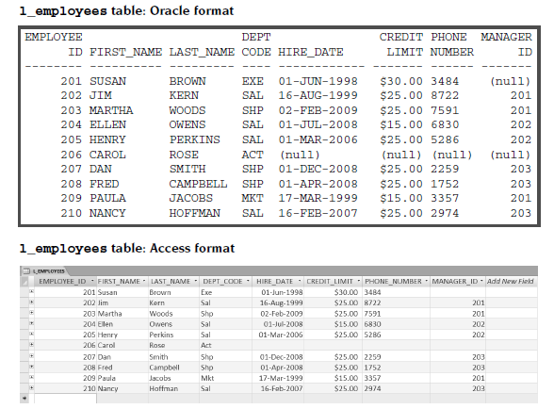

The other Oracle format is used in the “Database Home Page” environment. Here are a few of these differences:

■ Tables are displayed on pages in your Web browser.

■ Column headings are never truncated.

■ All fields are justified to the left.

■ Nulls are shown with dashes

■ Dollar amounts are not automatically formatted.

■ Oracle is mostly used in businesses with large databases. Hundreds of people may be using the database at the same time. The database can help coordinate all the people in a business and keep them working together.

■ Access is mostly used by individuals with small personal databases. Usually only one person is using the database at any given time. Access is also used in some business situations.